APPLICATION FOR GCA AWARD (SAMPLE- DUE NOV 15, 2025)
Date of Application Date you apply but before Nov 15 | Name of Award Applied for: Arbor Day  Send in to Program Chair for your Award by Nov 15 in 3 copies | Award No. 69
[X ] Garden Club [ ] Group of Clubs [ ] Individual [ ] Council or Federation | Name of Your Club
Name of Applicant (type exactly as name should appear on award) | Name of Your Club
Name of Person Submitting Award Application: Name | Title Club Awards Chairman or Club President Submitting
Address – Of person submitting | City City in which submitter lives | Zip zip code
E-mail Address submitter email address | No. of Members in Club: 22 | GCA District IV

1. New project? Yes _X___ No __ Beginning date: Jan 1, 2023 Completion date Nov 2023
2. Brief summary and objectives of project: (TOTAL NO MORE THAN 3 PAGES)
Goal: Planted a tree at a Historic Home in our community. Helped students plant a tree at their school yard. Since the state theme is to plant a Maple or Ginkgo Tree, “Add Color to Alabama in the Fall”, we chose to plant a Maple which provided color and shade at the local Elementary School.
Summary: Write a paragraph or two of what you did, where you started, what the finished product was, who was involved in as much detail as Type using 12 point font.
3. Involvement of club members, other organizations, etc.: List who participated, more points assigned when public, children, non club members, etc are involved.
4. Project expenses and means of funding: What money did you spend, where did it come from.

5.Continuing involvement, follow-up, maintenance: The Garden Club will do what to follow-up, maintain, or improve project.
6. Photos below: Add as many photos with descriptions (very important) of what you did. A picture is worth a 1,000 words. (DO NOT GO OVER 3 PAGES –SCAN or 3 COPIES TO PROGRAM CHAIR)
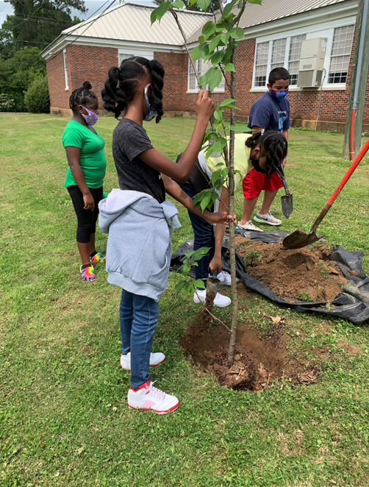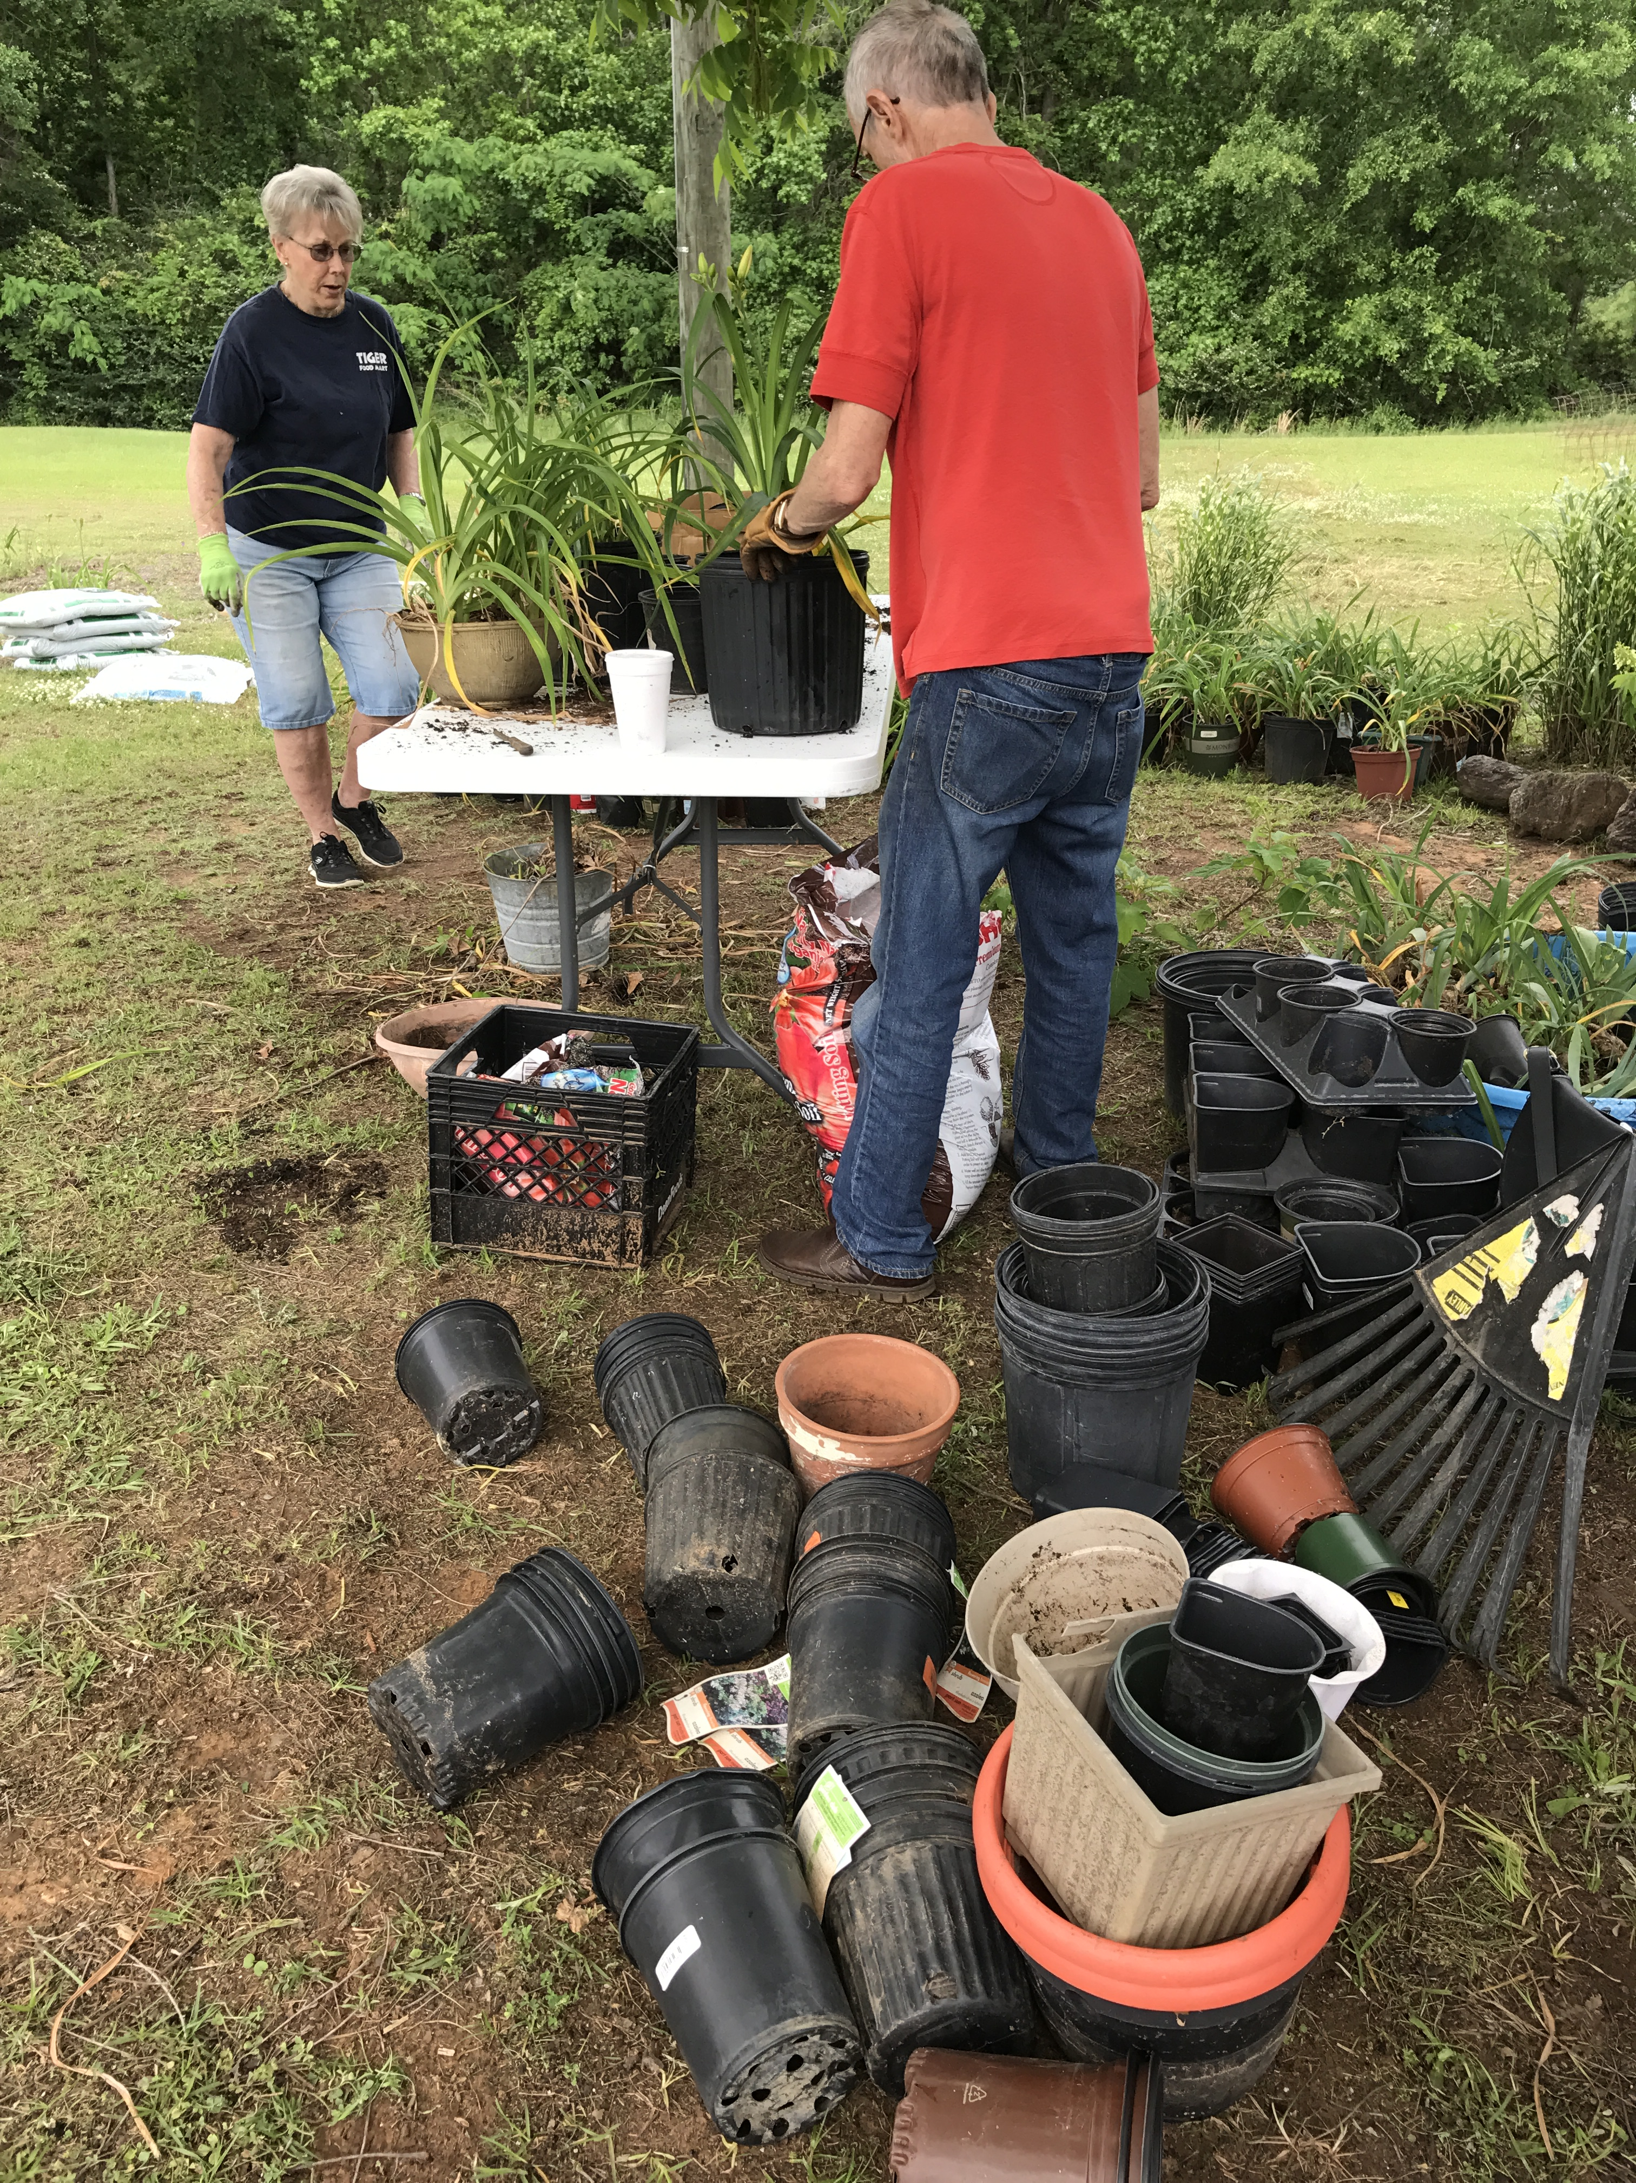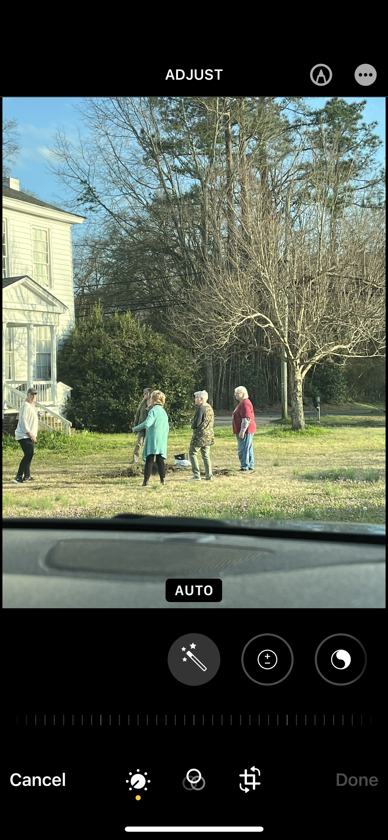
Students planting tree at Elementary Potting Plants for Resale Club Members Plant tee

