**District VII Meeting Registration Form**

**Wednesday, October 22, 2025**

**Registration 9:15 am Meeting 10 am**

|  |  |
| --- | --- |
| Name: | |
| Address | |
| Phone | Email |
| Club Name: | |

**Please check all that apply**

NGC Board Member_____ Deep South Board Member ____ Former State President _____

State Officer____ State Chair_____ Club President____ District Officer______

Former District Officer______ District Chair____ Guest_________

Life Member: National ____ Deep South____ GCA_____

Deadline for Registration: Friday, October 10, 2025

$30.00 (payable to Garden Club by the Lake)

**Please select one entrée**

___ Hamburger Steak ___Chicken

Send to: Doris Fenn, 804 Lake Front Dr. Abbeville, AL 36301

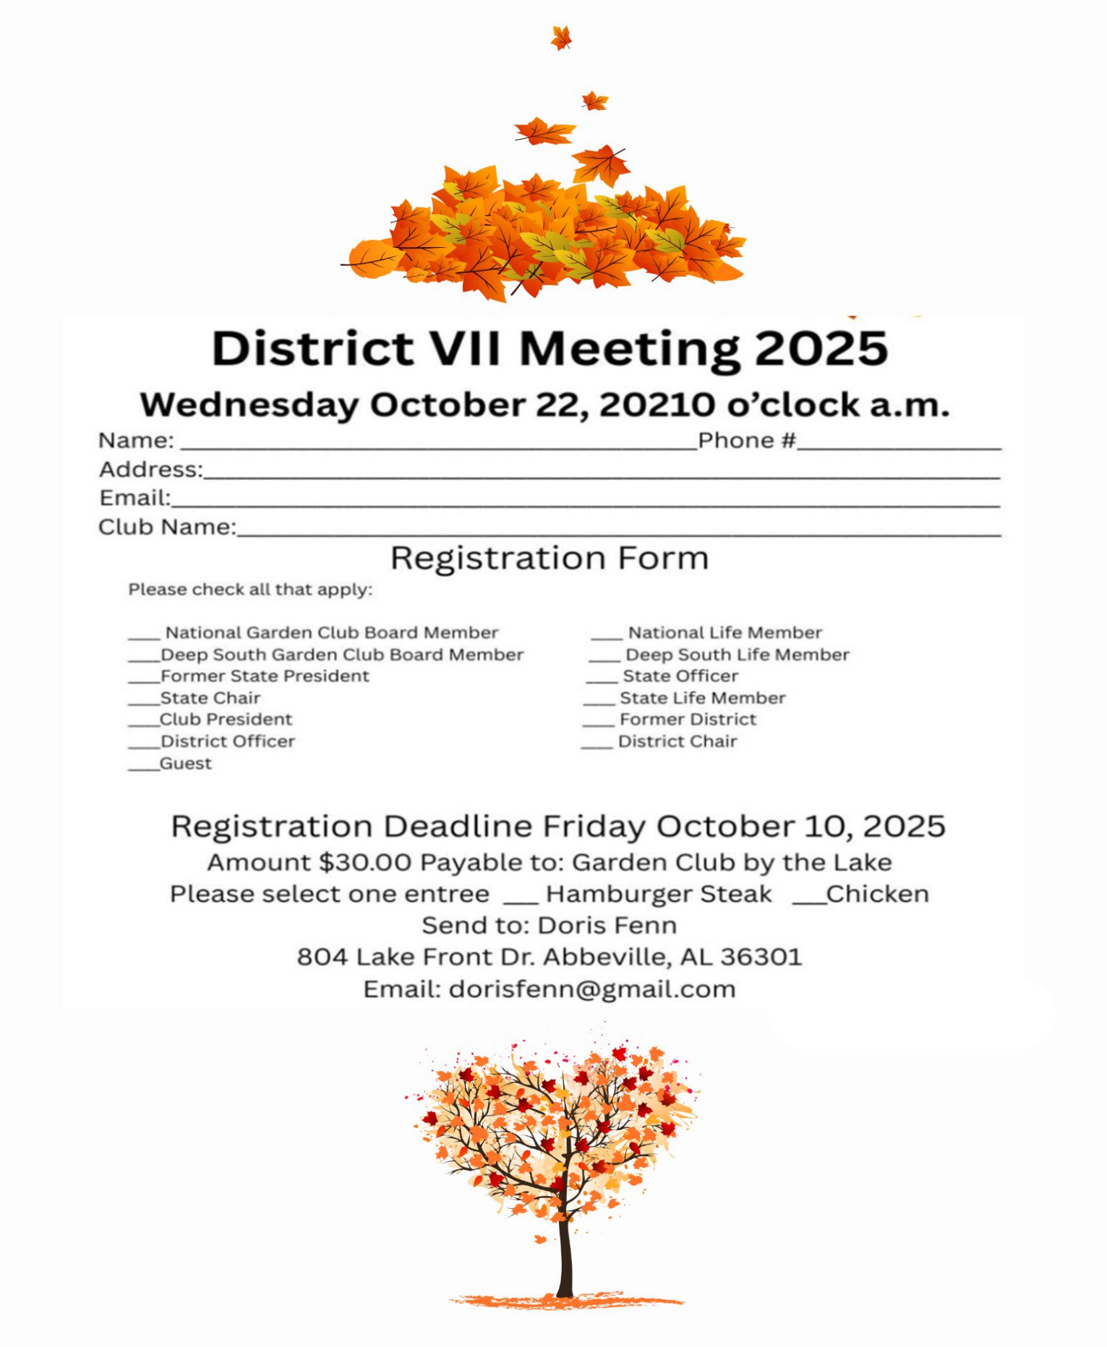Email: dorisfenn@gmail.com