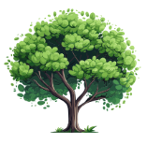
Garden Club of Alabama
Oak Tree Planting Contest

Date: ___________ Club Name: _______________________________
Individual Name: _________________________________
District: _________________________________________
Address: ________________________________________
________________________________________
Email Address: ____________________________________
Telephone Number: ________________________________

Number of Oak Trees Planted: ________________________
Attach at least one picture with the Form.

Send to kathymsudduth@gmail.com
(Attention Oak Tree Contest in the Subject Line.)
………………………………………………………………………………………………………………………
For Office Use
Facebook__________ Club____________
Web_______________ Individual________
Picture_____________

The Contest will run until the 2024 Convention in Opelika. Every Club or person that plants an oak tree will get recognized at the convention. I will also be awarding three cash prizes. Entry Deadline is March 1, 2024.

