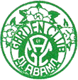 **The Garden Club of Alabama, Inc.**

**“In a State Where Gardens Grow, God Walks”**

**Dear (insert name or company)**

On April 28, 1932 , 71 delegates from 50 Alabama Garden Clubs met in Montgomery to organize the Alabama Federation of Garden Clubs. The organization’s history demonstrates the dedication to our goals:

* Aid in the protection and conservation of natural and human resources. • Encourage civic beauty, stimulate roadside development and discourage unsightly objects and litter along the highways. • Encourage the maintenance of a State Park system. • Further horticulture education and landscape design. • Study in all of its aspects the fine art of gardening.

After all these years we are pleased to say that The Garden Club of Alabama (GCA) is still making a difference in our communities and our state through civic beautification, scholarships, flower shows, and supporting the Blue Star Memorial marker program to honor our armed forces.

Our annual Convention is an important event that strengthens the organization through expert speaker knowledge and opportunities to connect with clubs across the state to collect and share new ideas for our communities. The next Convention will be held April 14-16, 2024 at the Auburn Mariott Opelika Resort and Spa at Grand National. We are seeking sponsorships from various businesses and organizations as well as individuals to support this event. We are writing to see if you would consider making a donation to help sponsor our event. By giving to the Garden Club of Alabama, you will help our organization to continue to make a difference throughout the state. In appreciation of your support we will place your name or company name on our donor board and in our convention program. Convention attendees are gardeners who come from all over Alabama. We hope that we can count on your support to make this year’s Convention exciting and meaningful to all involved.

Please fill out the enclosed form and send it back as indicated as soon as possible or no later than March 11, 2024.

Thank you in advance for your support. For more information contact the convention co-chairs

Sincerely,

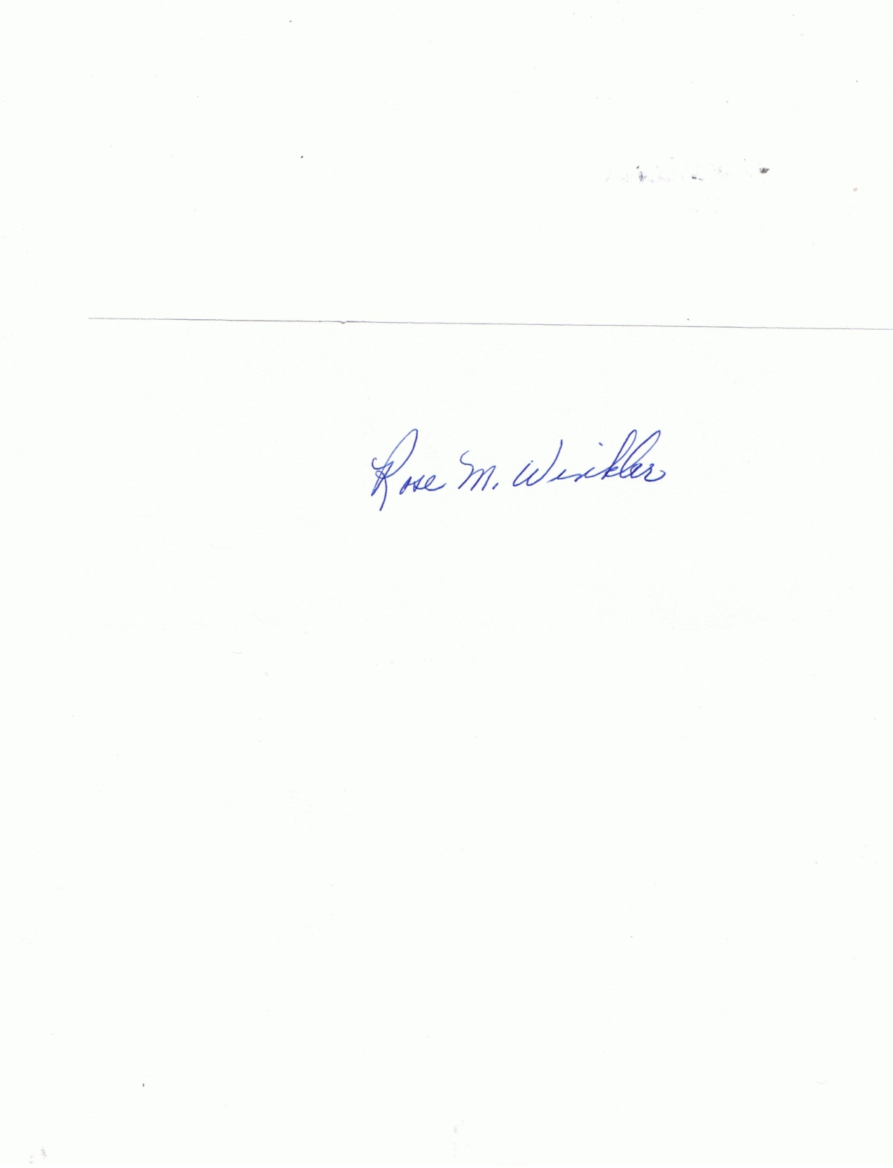

June Cyrus Rose Winkler

2024 Convention Co-Chair 2024 Convention Co-Chair

2730 Fernway Drive 5782 Carriage Barn Lane

Montgomery, AL 36111 Montgomery, AL 36116

334-313-0068 (cell) 334-313-2002 (cell)

[Junebug71050@aol.com](mailto:Junebug71050@aol.com) [rmwinkler45@yahoo.com](mailto:rmwinkler45@yahoo.com)