 **The Garden Club of Alabama, Inc.**

**“In a State Where Gardens Grow, God Walks”**

Dear (Patrons)

The Garden Club of Alabama 2024 Convention Committee is selling ad space in their 2024 Convention Booklet

Full Page $125.00

Half Page $ 75.00

Quarter Page $ 50.00

Eighth Page $ 25.00

There are two types of ads: Memorial and Regular Advertising Ads; ad orders are due by March 8, 2024. Please mark which type you would like to purchase.

_________ Memorial – Please include person’s name, club, city and district.   
 You can also include a picture of the person.

_________ Regular Advertising Ad – Tell us what size you want and send us   
 any artwork/text to be included.

Please make your check payable to The Garden Club of Alabama 2024 Convention with 2024 Convention Ad on the memo line.

Submit the checks and text information by March 8, 2024 to:

Pam Hattemer

677 Webb Drive

Prattville, AL 36067

[hattemerpam@gmail.com](mailto:hattemerpam@gmail.com)

334-546-8497 (cell)

We are looking forward to a great convention and thank you for your support.

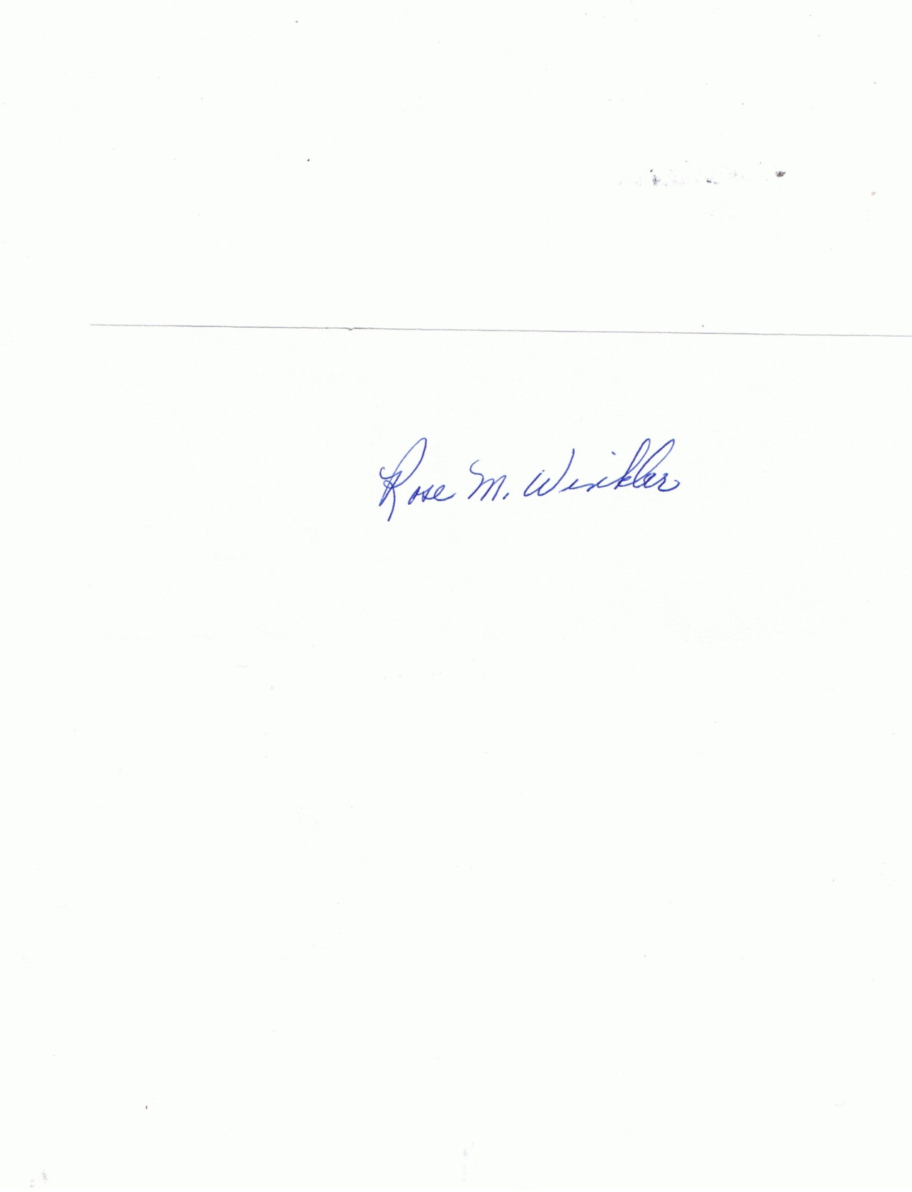

June Cyrus Rose Winkler

2024 Convention Co-Chair 2024 Convention Co-Chair

334-313-0068 334-313-2002

Junebug71050@aol.com rmwinkler45@yahoo