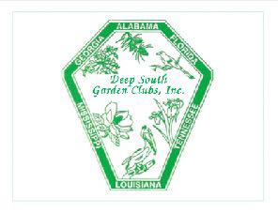
DSGC Awards Application 2017-2019

Mail entries to DSGC Awards Chairman (unless otherwise noted in DSGC Awards Rules. DSGC Website: www.dsregion.org)
Nancy Harris, 1190 Blake Court, Murfreesboro, TN 37130-9535, nancyharris1190@gmail.com, 615-890-7929 (h), 615-289-2917 (c)

Award#: Award Name: Date: Name of State: State Awards Chairman:
Chair Phone: Email:
[Enter name exactly as it should appear on any award received]
Name of Garden Club/Council: Number of members in club/council:
Location of Garden Club/Council (city): Contact Person: Phone: Email:
NOTE: Application form is limited to three printed pages, front of pages only. (No report covers or binders allowed. No plastic sheets allowed).
Please complete each topic, if applicable. Use numbering as below when completing form.
- New project: Yes No Beginning date: Completion date:
- Brief summary and objectives of project:
- Involvement of club members, other organizations, etc.:
- Project expenses and means of funding:
- Continuing involvement, follow-up, maintenance:
- Attach or insert photos, digital photos, and/or landscape plan (does not need to be professionally drawn).

